Name:__________________________

GEOL 1302

Plate Tectonics

In the first part of this lab, you are going to explore different methods of determining rates of plate motion. The second part deals with geologic features found at different types of plate boundaries. Please also refer to your textbook for a review of tectonic plates, plate boundaries, and plate motion. An additional useful source of information is the United States Geological Survey website http://pubs.usgs.gov/gip/dynamic/understanding.html.

Supplies needed for this lab: simple calculator, ruler

Please submit your lab online.

1. Under “Modules”, “Online Labs”, in the “Plate Tectonics” folder on Canvas, you find a map of the age of the ocean floor (based on paleomagnetic data and age data from rock samples). Find the oldest crust located at the east coast of North America. How old is it approximately?

The distance from this place to the Mid-Atlantic Ridge, where the crust initially formed, is about 1920 miles. What is the average rate of motion for North American Plate in miles per million years? Please show your work.

Now convert your answer into centimeters per year (Hint: There are 5,280 feet in one mile, 12 inches in one foot, and 2.54 cm in 1 inch), and please show your work. Check if your answer falls into the common range of plate motion (1-16 cm/yr) – if not, something went wrong with your calculation.

2. The map below shows the locations of the Hawaiian Islands with their ages in millions of years. What was the approximate average rate of movement of the Pacific Plate in cm/yr for the past ~5 million years? (Hint: Use the scale on the map to determine the distance between Hawaii, where the current hotspot activity is located, and a spot between Niihau and Kauai, where the hotspot was located approximately 5 million years. Then divide the distance by the age – don’t forget to convert your result into cm/yr). Please show your work.

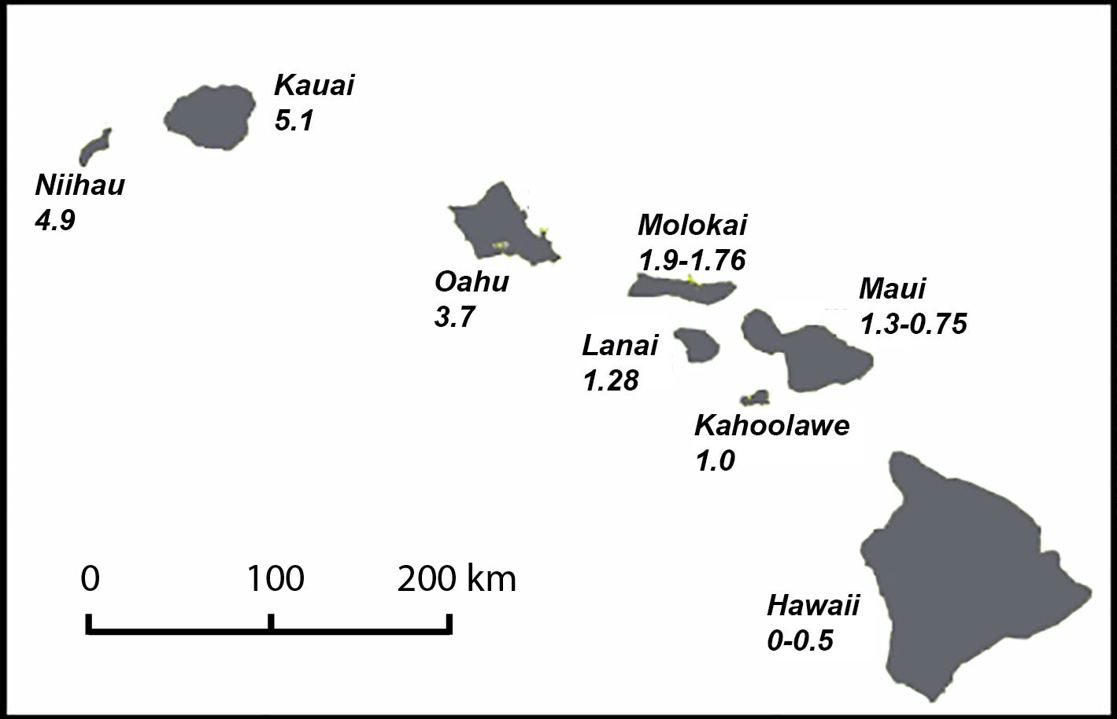

3. On the volcano map found in the same folder as mentioned in question 1, compare the west coast of North America with its east coast. What differences do you observe? What is the likely plate-tectonic explanation for these differences?

4. Below you find a table with earthquake data for South America from 1993 to 1994. Plot the longitude (horizontally) vs. depth (vertically) in the graph below. What do you notice about the earthquake foci as you go from west to east ( = further inland from the west coast)? What appears to be happening to the two plates that meet at the west coast of South America?

