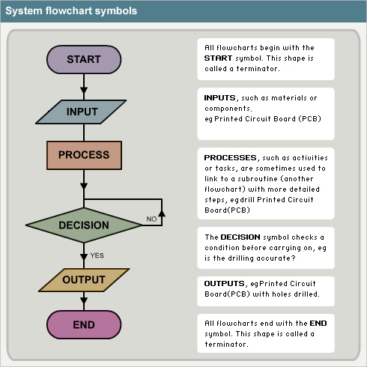

http://farm3.staticflickr.com/2625/4070163768_02a7d80326.jpg

